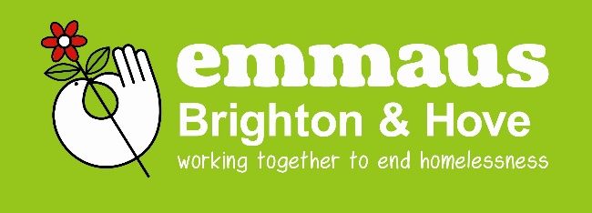

Support Emmaus Brighton & Hove

If you would like to make a donation to help support the work of Emmaus Brighton & Hove, you can do so by the following means:

- Visit https://localgiving.org/charity/emmausbrighton/ make a one off donation or set up a regular monthly donation

- You can make a Bank Transfer directly to our account:
Account name: Sussex Emmaus
Sort Code: 40-52-40
A/c no: 00008042
………………………………………………………………………………………………

- If you prefer you can donate by cheque
I enclose a cheque for £_______ (please make cheque payable to Sussex Emmaus)

If you would like to Gift Aid your donation, please complete the
Gift Aid Declaration below.

Please complete if you are a tax payer
I want the charity to treat this donation and all future donations until further notice as Gift Aid donations.

Title ______ First Name(s) _________________________
Surname________________________________________
Home Address___________________________________
________________________ Postcode _______________
Signature ___________________Date _______________
Notes:
- You must pay an amount of income tax and/or capital gains tax at least equal to the tax that the charity
reclaims on your donations in the tax year.
- You can cancel this declaration at any time by notifying us.
- If in future your circumstances change and you can no longer pay tax on your income or capital gains
equal to the tax that the charity reclaims, you can cancel your declaration.
- If you pay tax at the higher rate you can claim further tax relief in your Self Assessment tax return.
- If you are unsure whether your donations qualify for Gift Aid tax relief please contact us or ask your local tax office for leaflet IR113 Gift Aid.
- Please notify us if you change your name or address

Please return this form to:
Emmaus Brighton & Hove, Drove Road, Portslade, BN41 2PA
Christmas 2019

Data Protection: Sussex Emmaus is registered with the Information Commissioner’s Office and will process all personal information fairly and lawfully and for a specified purpose. If you have any queries regarding data protection or if you no longer wish to hear from us please contact us.
Emmaus Brighton & Hove is a community of Sussex Emmaus which is a company limited by guarantee No. 3130876 and a Registered Charity No: 1053354

